Experiment :- 20

Problem statement:-
Mathematical computations such as finding the Greatest Common Divisor (GCD), Least Common Multiple (LCM), and checking whether a number is prime are fundamental problems in programming and algorithm design. Automating these computations using shell scripting helps students understand arithmetic operations, conditional logic, and iterative constructs in Bash.
The problem is to write a shell script that accepts user input to compute the GCD and LCM of two numbers and checks whether a given number is prime, demonstrating arithmetic operations, loops, and decision-making in Bash scripting.

Aim:- Shell script to compute GCD. LCM and check whether a given number is prime.

Procedure:-
A. Writing the Shell Script
1. Open the terminal.
2. Create a script file: nano math_ops.sh
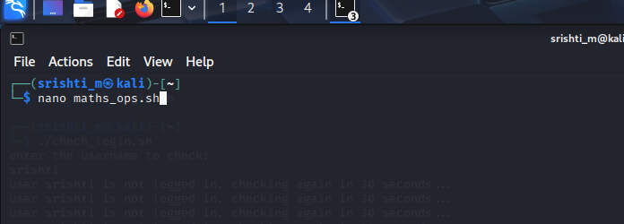

3. Enter the script:
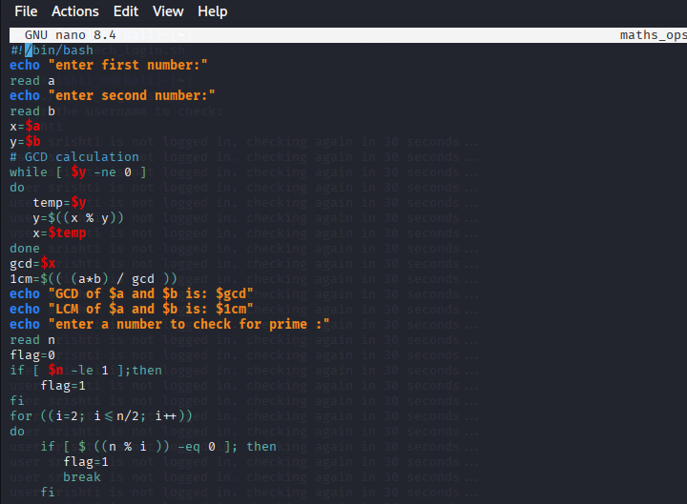
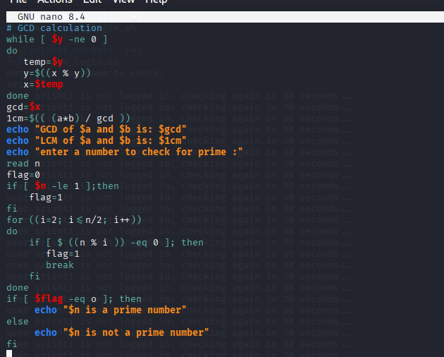
4. Save and exit the editor.
5. Make the script executable: chmod +x math_ops.sh
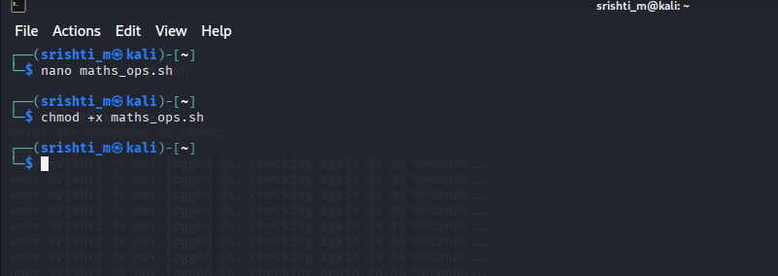
B. Executing the Script 6. Run the script:
7. ./math_ops.sh
